*AN AWARD WINNER INTERNATIONAL ORGANIZATION*

A_



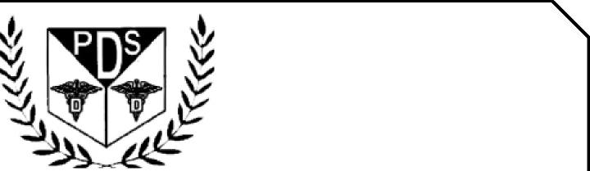

PROMOTING EXCELLENCE IN DENTAL EDUCATION   
Over 7000 Members Strong

**Presents**

A Must attend seminar for you and your staff

**CALIFORNIA LAW, INFECTION CONTROL & RISK MANAGEMENT**

**BY**

**BIJAL JOSHI ESQ, MARC F LEFFLER DDS ESQ, DR RAMNEEK RAI DDS**

**ONLINE LIVE WEBINAR**



**On   
OCT 19TH, 2025 (Sunday) 8:00 am till 3:00 pm   
(CA Board 7 hrs C.E. units)   
at**

**(THIS INTERACTIVE WEBINAR IS CONSIDERED BY CA DENTAL BOARD AS LIVE COURSE)**

(Please print in capital letters or attach your business card)

Name DR/RDH/RDA/DA Lic no

|  |  |  |  |
| --- | --- | --- | --- |
| Circle one First Middle Initial Last | |  |  |
| Address |  |  |  |

City State Zip

Cell no ________________ Accept text message yes/no E-Mail________________________________________

**ARE YOU A PDS MEMBER: YES/ NO**

|  |  |  |
| --- | --- | --- |
| REGISTRATION FEE |  |  |
| Dentists Non-members | $80.00 |  |
| Members | $70.00 |  |
| Hygienist/R.D.A. Non-members | $70.00 |  |
| Members | $60.00 |  |

FOR REGISTRATION

CALL TOLL FREE 1-866-422-5573 (1-866-4-CALL-PDS) OR 909-933-9076   
**TO REGISTER ONLINE VISIT US ON WWW** [**PDSOCIETY. COM**](http://PDSOCIETY.COM)

Make check payable to

Dr. R. Salwan

President



PDS

124 EAST F STREET SUITE #8 ONTARIO, CA 91764

Dr. D.P. Singh Nagra

Chairman



**DR BIJAL JOSHI**

Dr. Bijal Joshi is a practicing dentist and a lawyer.  Dr. Joshi has bought and sold her multiple dental practices in California and Florida.  Dr Joshi has been practicing dentistry for over 20 years.  Her law practice is primarily focused on helping dentists with their practice transition, lease agreements, real estate transactions, purchase agreements, corporations, associate agreements and business transactions.   Dr Joshi was also a faculty member at UCLA dental school.  Besides work, Dr Joshi loves to spend time with her two boys, family and friends.  She is a student pilot learning to fly single engine planes at Chino Airport.

**MARC R.LEFFLER DDS ESQ**

Dr. Marc Leffler received his D.D.S. degree from Columbia University, after which he completed residency training in oral and maxillofacial surgery at Bellevue Hospital Center/New York University, subsequently becoming board-certified in oral and maxillofacial surgery. Dr. Leffler then received his law degree from New York Law School, serving as a member and editor of the Law Review, and went on to practice trial law in New York, representing dentists and dental specialists in dental malpractice litigation, dental board disciplinary actions, and peer review proceedings. Outside of professional activities, he serves as a United States Coast Guard Auxiliary Flotilla Commander and a Flotilla Staff Officer. After representing MedPro’s insureds as an attorney for years, he joined MedPro as an oral surgery and dental consultant prior to working in his current position as Dental Risk Solutions Lead. Dr. Leffler regularly provides closed malpractice case study articles, known as Malpractice Minutes, which discuss underlying case facts, the litigation events, and a series of risk management takeaways; these are sent to MedPro insureds, dental students, and specialty residents. Additionally, Dr. Leffler has provided risk management presentations to student groups and dental associations. He works closely with MedPro’s dental risk team to serve the risk needs of insureds. Risk Solutions is an integral commitment of MedPro.

**RAMNEEL RAI DDS**

**Director of Health and Safety**

**UCSF School of Dentistry**

With more than 10 years of private practice experience and in serving as Director of Health and Safety at UCSF School of Dentistry, Dr. Rai has extensive knowledge and expertise in dental infection prevention. At UCSF, she teaches infection prevention, control, and safety practices, as well as supports predoctoral students and residents. She also provides health and safety oversight for 17 UCSF Dental Center clinics and led the center through the COVID-19 pandemic. Dr. Rai serves as Director on the Organization for Safety, Asepsis and Prevention (OSAP) Association Board and Secretary to the OSAP Board. She completed her dental education at Dasmesh Institute of Dental Sciences in India and is an alum of the International Dentist Program at UCSF

EVENT SPONSORED BY PUNJABI DENTAL SOCIETY AND MED-PRO